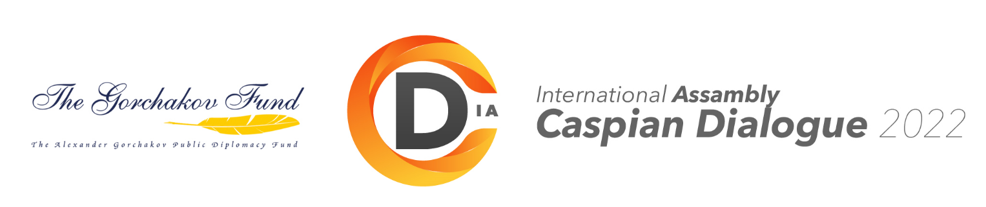

application
TO PARTICIPATE IN THE IN-PERSON MEETING OF THE INTERNATIONAL ASSEMBLY "CASPIAN DIALOGUE"
MAY 11, 2022.
Organization
Postal and legal
address of the organization (with an index)
Last name, first name,
patronymic of the participant:
Academic title, academic degree
participant:
Position in the participant's company/organization:
Topic of the report/presentation
Participant's contact information : | Website | Phone numbers | E-mail
Contact person:

(tel., mob.t., e-mail)
Types of packages of the participant of the face-to-face meeting |  |  | Cost € | mark
The VIP participant package includes:  1. participation in the work of all IACDi events (preferential right to make a report on a preliminary application)  2. making a presentation  3. provision of 2 sq.m. of unequipped exhibition space (a stand with a safety certificate is provided by the Customer)  4. the possibility of organizing a poster presentation  5. one set of information materials  6. information center services  7. workplace for organizing business meetings  8. participation in official business meetings  9. coffee breaks  10. lunch  11. free participation of an accompanying person |  |  | 700
The business participant package includes:  1. participation in the work of all IACDi events (the right to make a report on a preliminary application)  2. making a presentation  3. one set of information materials  4. information center services  5. participation in business meetings  6. coffee breaks  7. lunch  8. participation of an accompanying person with an additional payment under the "Business visit" package (payment with a 10% discount) |  |  | 450

We hereby confirm our agreement with the Terms of Participation. We guarantee payment for the ordered services
according to the invoice issued by the Organizer. If you refuse to participate in less than 20 days, we guarantee
payment of the penalty in accordance with the Terms of participation. The application may be accepted by the Organizer for execution
upon payment of the registration fee.
Date of filling in_____________ Signature__________ /__________________/

Please send an application to the IACDi Organizing Committee by February 25, 2022 by e-mail: caspiancouncil@mail.ru, ndlevshina@mail.ru

Contact persons: Ilya Levshin (+79996679005), Viktor Kovtun (+79161319059).
www.caspiansovet.ru, http://caspiandialogue.ru

